**School of Computer Science and Engineering**

**AY 23/24, SC2002: Object Oriented Programming**

**Seminar Class: SDDA**

**Group:** **1**

We hereby declare that the attached group assignment has been researched, undertaken, completed, and submitted as a collective effort by the group members listed below.

We have honoured the principles of academic integrity and have upheld Student Code of Academic Conduct in the completion of this work.

We understand that if plagiarism is found in the assignment, then lower marks or no marks will be awarded for the assessed work. In addition, disciplinary actions may be taken.

|  |  |  |  |
| --- | --- | --- | --- |
| Name | Course | Lab Group | Signature /Date |
| Justin Loh Teng Hao  U2220126L | SC2002 | SDDA G1 | | 24-04-24 |
| Lim Kiat Sen, Jaron  U2222010K | SC2002 | SDDA G1 | | 24-04-24 |
| Ian Boo Jing Yong  U2222374H | SC2002 | SDDA G1 | | 24-04-24 |
| Andy Chan Yan Meng  U2221216B | SC2002 | SDDA G1 | | 24-04-24 |
| Koh Jia Hui Rachel  U2222747H | SC2002 | SDDA G1 | | 24-04-24 |

# 1. Design Considerations

## 1.1 Design Strategies

We approached the design of the Fast-food Ordering Management System (FOMS )with the intention to achieve a consistent high level of cohesion, and loose coupling. As such, we adopted a three-layer architecture, with a presentation layer, business logic layer and database layer. Our presentation layer comprises boundary objects that handle user inputs and outputs, effectively acting as our user interface, communicating with the business logic layer to retrieve data and perform actions based on user input. The business logic layer comprises control classes which contain our application’s logic, rules and workflows for each use case, encapsulating the core functionality. This middle layer communicates with the presentation layer for receiving user input and providing output, while communicating with the data access layer for retrieving and persisting data. Lastly, our data access layer comprises data access objects, responsible for interacting with our entity classes through creating, reading, updating and deleting of content in our serialised data to achieve data persistence.

## 1.2 Key Strategies enabling Extensibility and Maintainability

Throughout our process in developing the system, we focused on ensuring modularity with the system. We were able to break our system down into smaller, manageable and interchangeable use cases for development, while communicating possible shared functions for inheritance. This allowed us to develop, test and debug the system independently, while also ensuring that one module is less likely to impact other modules, thus enhancing maintainability.

At the same time, we placed much emphasis on utilising polymorphism for functionalities we wished to implement. This promotes a reusable architecture that anticipates change and promotes flexibility, its implementation aligned with our focus on modularity and makes it easier to modify and extend the system without altering its core structure.

Lastly, we programmed interfaces by first defining the capabilities of a class without tying it down to a specific implementation. This thus enabled us to be clear on the methods of classes, while enabling continuous refactoring of our code, promoting the maintainability of our system.

## 

## 1.3 Assumptions Made

We have implemented a 2 hour limit for customers to collect their order, which is refreshed whenever the order DAO is instantiated. This time limit is based on the recommended amount of time food can be left out before becoming hazardous to human health, ensuring that the food collected by customers is fresh and safe. We also assumed that an order is only prepared by a kitchen after it has been paid for by customers.

# 2. Applied Design Principles

## 2.1 Single Responsibility Principle: *"A module should be responsible to one, and only one, actor."*

In the presentation layer, boundary objects have the sole purpose of interfacing with the user, collecting inputs and presenting outputs, without involving any business logic or handling of data. These boundary objects are further segregated into the staff or customer function it is associated with, thus forming its respective forms that are generated from the user’s choice. In doing so, each class has only one reason to change, and each class is tasked with a specific functionality that does not overlap with responsibilities of other classes. This thus minimises the effect of changes by increasing the encapsulation and modularity of our system, increasing our ease in understanding, testing and refining.

## 2.2 Open/Closed Principle (OCP): *“Software entities (classes, modules, functions, etc.) should be open for extension, but closed for modification”*

OCP is applied throughout our system, but is most prominent in our customer payment use case OCP is applied by creating a strategy interface, “PaymentService”, whose methods “simulatePayment()” and “authenticatePayment()” is implemented by the respective payment services, such as “OnlinePaymentService” and “CreditDebitPaymentService”. As such, should one wish to add a new payment method, for instance by cash, new behaviours can now implement the PaymentService interface, allowing for the addition of new behaviours with minimal changes to existing code, demonstrating both inheritance and polymorphism, as the payment method called is bound dynamically.

## 2.3 Liskov Substitution Principle (LSP): *“Let 𝜙(𝑥) be a property provable about objects 𝑥 of type T. Then 𝜙(𝑦) should be true for objects 𝑦 of type S where S is a subtype of T.”*

We apply LSP throughout our system for any interface used. For instance, we ensure that objects created by the factory are always instances of a type that is suitable for the base interface “Form”, which the factory promises to return. This ensures that each Form can be treated the same as any other form that conforms to the interface, fulfilling LSP as it guarantees that subclasses are proper substitutes for their Form interface. Moreover, adhering to LSP guarantees the extensibility and modularity of strategies and facades mentioned in 2.2, since its modular nature is contingent on a class being treated the same as any other class that inherits the same interface, creating its “swappable” ability.

## 2.4 Interface Segregation Principle (ISP): *“No code should be forced to depend on methods it does not use.”*

When designing our system, we abided by the ISP to shape our interfaces to be lean and client-specific, preventing the “fat interface” problem where an interface has more methods than its clients need or use. For instance, despite StaffApp and the respective views having similar methods of calling a boundary class, we separated them to create two interfaces: StaffView and AppDisplay. This ensures that our app and views only implement their necessary methods, without being burdened by irrelevant functionalities that do not apply to its specific processing needs.

## 2.5 Dependency Inversion Principle (DIP): *“A. High-level modules should not import anything from low-level modules. Both should depend on abstractions (e.g., interfaces). B. Abstractions should not depend on details. Details (concrete implementations) should depend on abstractions.”*

The DIP is seamlessly integrated into our system through the use of a facade pattern in “Forms”. By interacting with the “Form” interface, high-level functionalities in “CustomerApp” are unaffected by changes in the specifics of lower-level forms such as “CustomerOrderingForm” for customer ordering functions or “CustomerPostPaymentForm”, for customer payment functions. This decouples the high-level functionalities from the specifics of its underlying implementations, thus adhering to DIP by solely depending on its “Form” abstraction. This thus enables us to add more customer functionalities with the least effort needed in the future, extending the functionalities in our system.

# 3. Current Improvements

## 3.1 Concurrent Updates to Database

For improvements of our system, we considered the situation when there are concurrent customers ordering and staff members preparing orders. Initially, as the system was built for one user’s access, updates to the database only occur when a use case has finished. Thus, we refactored the controllers to call for its respective data access object to save the data upon any confirmed change, directly affecting the serialised object and maintaining data uniformity amongst users. Additionally, we implemented an automatic refresh of the data contained within the data access objects that occurs whenever any option is selected, creating ease in the checking of updates.

## 3.2 User Experience

We have improved user experience with our system by displaying all required information to the user whenever a choice is necessary. For instance, when a customer is prompted to enter the branch they are in, we will first display all possible branches. As such, users gain a better experience with our system’s interface, thus increasing its effectiveness.

**4. Future Improvements**

**4.1 Change in Data Format**

Due to specified constraints, the storage of data is in the form of a Microsoft Excel Open XML Format Spreadsheet (XLSX) file. Since XLSX is used by Microsoft Excel, a common program used for administrative work, saving it in such a format enables better integration with the Fast-food restaurant’s administrative processes. However, our current implementation involves rewriting the entire file for each update, which can be computationally costly, and creates the possibility of data inconsistencies should two independent processes write to the same file. In the future, usage of a database application would be preferred to handle the possibility of concurrent updates to the database at the same time.

**5. Detailed UML Class Diagram (Please refer to Image attached for clearer View)**

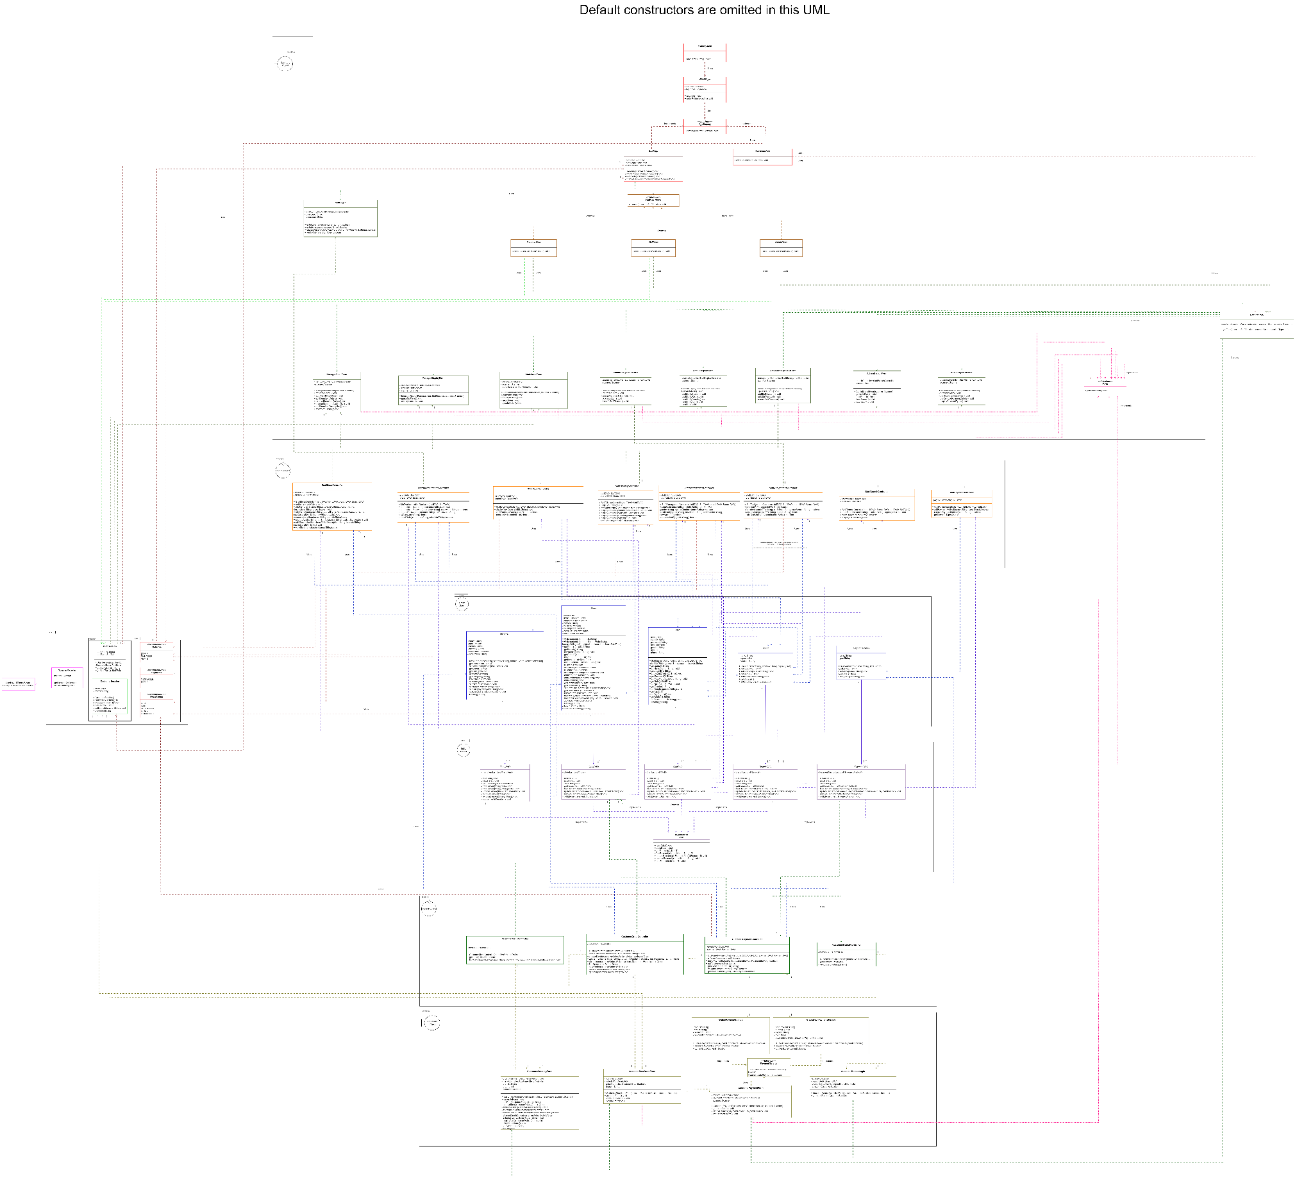

# 

# 6. Testing (Please watch the Screen Recordings for more detailed Live-Demos + Error Handlings)

**6.1 Manager’s action: Menu Management**

|  |  |
| --- | --- |
| **Test Case 1:** Add new menu item with unique name, price, description, category and verify the menu item is added successfully. |  |
| **Test Case 2:** Update the price and description of an existing menu item, and verify that the changes are reflected in the menu.  (Negative price handling shown in the video) |  |
| **Test Case 3:** Remove an existing menu item. Verify that the menu item is no longer available.  (Unknown branch handling shown in the video) |  |

**6.2 Order Processing:**

|  |  |
| --- | --- |
| **Test Case 4:** Place a new order with multiple food items, customise some items, and choose takeaway option, and verify order is successfully created. |  |
| **Test Case 5:** Place new order with dine-in option, and verify order is created with correct preferences.  (Invalid input for dine-in/takeaway selection shown in the video)  (User friendliness - Ability to change from dine-in to takeaway shown in Supplementary Video 1, and ability to remove and add items into cart in Supplementary Video 2) |  |

**6.3 Payment Integration:**

|  |  |
| --- | --- |
| **Test Case 6:** Simulate a payment for using a credit/debit card, and verify that the payment is processed successfully. |  |
| **Test Case 7:** Simulate a payment using an online payment platform (e.g. PayPal) and verify that the payment is processed successfully.  (Scenario where customer tries to pay for an order that is already paid for is shown in the video)  (Scenario where customer enters an invalid payment type covered in Supplementary Video 3) |  |

**6.4 Order Tracking:**

|  |  |
| --- | --- |
| **Test Case 8:** Track the status of an existing order using the order ID, and verify that the correct status is displayed.  (Invalid input for order ID that has not yet been created is shown in the video) |  |

**6.5 Staff Actions:**

|  |  |
| --- | --- |
| **Test Case 9:** Login as a staff member and display new orders, and verify that the staff can see all the new orders in the branch he/she is working.  (Explanations in the video to show the verification for all new orders, which in our case is based on our assumption that orders that are placed and paid for by customers. These are orders that are ready to be prepared by the kitchen staff at the restaurant) |  |
| **Test Case 10:** Process a new order, updating its status to “Ready to pickup”, and verify that the order status is updated correctly. |  |

**6.6 Manager Actions:**

|  |  |
| --- | --- |
| **Test Case 11:** Login as manager and display the staff list in the manager’s branch, and verify that the staff list is correctly displayed.  (Explanations in the video to show that the staff list is correctly displayed) |  |
| **Test Case 12:** Similar function as test case 10 - Process Order  (Invalid input for order ID that has not yet been created is shown in the video) |  |

**6.7 Admin Actions:**

|  |  |
| --- | --- |
| **Test Case 13:** Close a branch, and verify that branch does not display in Customer’s Interface anymore. |  |
| **Test Case 14:** Login as an admin and display the staff list with filters (branch, role, gender, age), and verify that the staff list is correctly filtered.  (Explanations in the video to show that the filter is working correctly)  (Supplementary Video 4 shows the error handling of the wrong inputs as filters) |  |
| **Test Case 15:** Assign managers to branches with the quota/ratio constraint, and verify that managers are assigned correctly.  (Explanations in the video on handling of checking of constraints) |  |
| **Test Case 16:** Promote a staff to branch Manager, and verify that the staff is promoted successfully. |  |
| **Test Case 17:** Transfer a staff/manager among branches, and verify that the transfer is reflected in the system.  (Invalid branch entered handling is shown in the video) |  |

**6.8 Customer Interface**

|  |  |
| --- | --- |
| **Test Case 18:** Place a new order, check the order status using the order ID, and collect the food. Verify that the order status changes from “Ready to pickup” to “completed”  (Explanations in the video of the whole process, including error handling of customer trying to pick up order when it is not ready) |  |

**6.9 Error Handling:**

|  |  |
| --- | --- |
| **Test Case 19:** Attempt to add a menu item with duplicate name, and verify that an appropriate error message is displayed |  |
| **Test Case 20:** Attempt to process an order without selecting any items, verify that an error message prompts the user to select items. |  |

**6.10 Extensibility:**

|  |  |
| --- | --- |
| **Test Case 21:** Add a new payment method, verify that the new payment method is successfully added.  (Explanations in the video on extensibility) |  |
| **Test Case 22:** Open a new branch, verify that the new branch is added without affecting existing functionalities  (Explanations in the video on extensibility) |  |

**6.11 Order Cancellation:**

|  |  |
| --- | --- |
| **Test Case 23:** Place a new order and let it remain uncollected beyond the specified timeframe, and verify that the order is automatically cancelled and removed from the “Ready to pickup” list.  (Explanation found in the video) |  |

**6.12 Login System:**

|  |  |
| --- | --- |
| **Test Case 24:** Attempt to log in with the incorrect credentials as a staff member, verify that an appropriate error message is displayed  (Explanation on error handling found in the video) |  |
| **Test Case 25:** Login as a staff member, change the default password, and log in again with the new password, and verify that the password change functionality works as expected  (Verification of successful login can be seen in the video) |  |

**6.13: Staff List Initialization**

|  |  |
| --- | --- |
| **Test Case 26:** Upload a staff list file during system initialization.  Verify that the staff list is correctly initialised based on the uploaded file.  (Explanation found in the video) |  |

**6.14: Data Persistence**

|  |  |
| --- | --- |
| **Test Case 27:** Perform multiple sessions of the application updating, adding and removing menu items, and verify that changes in 1 session persist and are visible in subsequent sessions.  (Explanations found in the video) |  |

# 

# 7. Reflection

From this assignment, we have seen the importance of design considerations with regards to SOLID principles through real application. Initially, we had built functional code without design considerations, resulting in a monolithic architecture where any change in our code triggered a ripple effect. This resulted in a lot of time spent in maintaining code and updating it. Eventually, realising that our methods were wrong, we decided to redo the project. In our second iteration, we split the system into use cases, and utilised a UML class diagram to have a visual understanding on whether we have achieved the intended loose coupling with high cohesiveness. At the same time, while developing our UML diagram, we challenged each other’s suggestions as to whether they abided by the SOLID principles.

We were thus able to develop the system in parallel, maximising our time usage which was key as we were already set back due to our prior failed instance. With our newly developed system, we found that maintenance was much easier, and we were thus able to perform code refactoring frequently during the development process, while creating more functionalities such as payment methods that were easily extendable. Overall, we have realised the importance of planning and designing with SOLID principles in mind, not just for the high cohesion and loose coupling that enables the high flexibility, easy maintenance and easy extension, but also for the modularity it enables which enables parallel development, ensuring effective and efficient teamwork.